http://lists.us.dell.com/

20160325
# I have subscribed to one subscription.
#
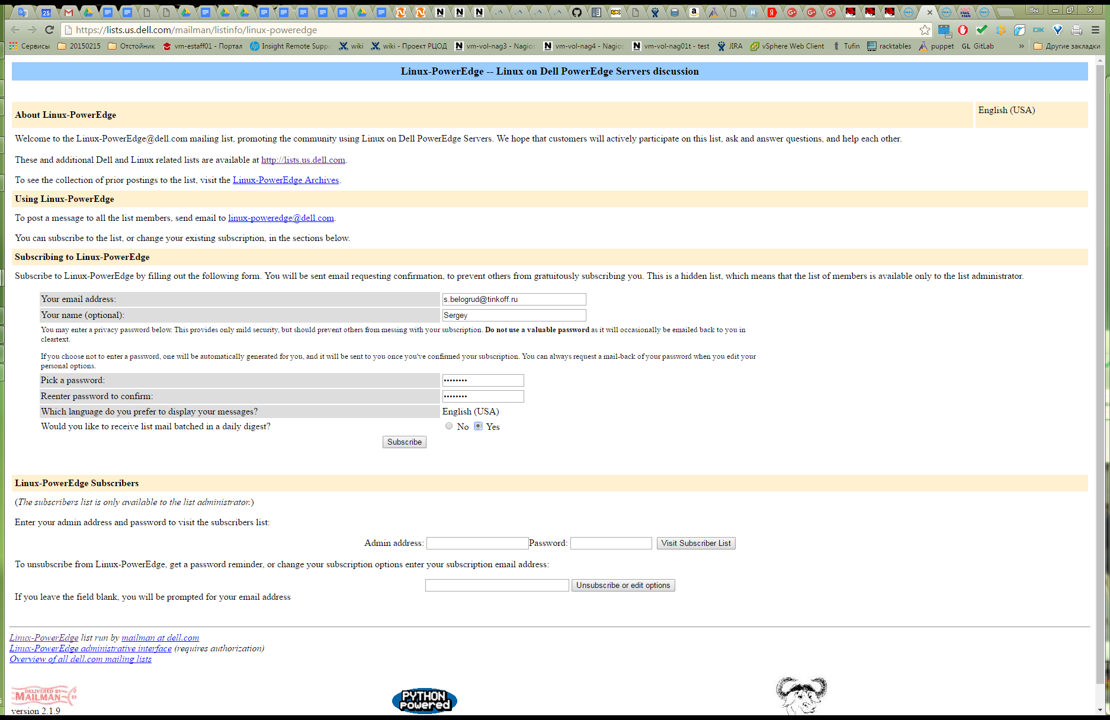

Password: Qw123456

-----Original Message-----
From: linux-poweredge-bounces@dell.com [mailto:linux-poweredge-bounces@dell.com] On Behalf Of linux-poweredge-request@dell.com
Sent: Friday, March 25, 2016 5:55 PM
To: Belogrud Sergey Vladimirovich
Subject: Welcome to the "Linux-PowerEdge" mailing list (Digest mode)

Welcome to the Linux-PowerEdge@dell.com mailing list!

To post to this list, send your email to:

linux-poweredge@dell.com

General information about the mailing list is at:

https://lists.us.dell.com/mailman/listinfo/linux-poweredge

If you ever want to unsubscribe or change your options (eg, switch to or from digest mode, change your password, etc.), visit your subscription page at:

https://lists.us.dell.com/mailman/options/linux-poweredge/s.belogrud%40tinkoff.ru

You can also make such adjustments via email by sending a message to:

Linux-PowerEdge-request@dell.com

with the word `help' in the subject or body (don't include the quotes), and you will get back a message with instructions.

You must know your password to change your options (including changing the password, itself) or to unsubscribe. It is:

Qw123456

Normally, Mailman will remind you of your dell.com mailing list passwords once every month, although you can disable this if you prefer. This reminder will also include instructions on how to unsubscribe or change your account options. There is also a button on your options page that will email your current password to you.

-----Original Message-----
From: linux-poweredge-bounces@dell.com [mailto:linux-poweredge-bounces@dell.com] On Behalf Of linux-poweredge-request@dell.com
Sent: Friday, March 25, 2016 5:54 PM
To: Belogrud Sergey Vladimirovich
Subject: confirm 29dcf421c21f1f8f615be4c7871a0fe87fcf7f5d

Mailing list subscription confirmation notice for mailing list Linux-PowerEdge

We have received a request from 91.194.226.234 for subscription of your email address, "s.belogrud@tinkoff.ru", to the linux-poweredge@dell.com mailing list. To confirm that you want to be added to this mailing list, simply reply to this message, keeping the
Subject: header intact. Or visit this web page:

https://lists.us.dell.com/mailman/confirm/linux-poweredge/29dcf421c21f1f8f615be4c7871a0fe87fcf7f5d

Or include the following line -- and only the following line -- in a message to linux-poweredge-request@dell.com:

confirm 29dcf421c21f1f8f615be4c7871a0fe87fcf7f5d

Note that simply sending a `reply' to this message should work from most mail readers, since that usually leaves the Subject: line in the right form (additional "Re:" text in the Subject: is okay).

If you do not wish to be subscribed to this list, please simply disregard this message. If you think you are being maliciously subscribed to the list, or have any other questions, send them to linux-poweredge-owner@dell.com.

